

**The MPC’s forecasts and the yield curve: predictions versus promises**

Speech given by

Ben Broadbent, Deputy Governor Monetary Policy

Reuters, Canary Wharf Wednesday 18 November 2015

I would like to thank Clare Macallan for research assistance and I am grateful for helpful comments from other colleagues. The views expressed are my own and do not necessarily reflect those of the

Bank of England or other members of the Monetary Policy Committee.

Good morning!

The previous Governor of the Bank, Mervyn King, once referred to what he called the “rich seam” of MPC communication. Rich or not, it’s certainly a wide seam: MPC members each give several speeches a year; we publish minutes of every meeting, now supplemented with a Monetary Policy Summary; every quarter we publish a 50-page Inflation Report that summarises the MPC’s collective view of the economic outlook and includes our latest forecasts; every Report is followed by a session in front of parliament’s Treasury Committee.

Yet, from all this, the outside world seems increasingly interested in only one particular nugget: the MPC’s central inflation forecast two years ahead. This forecast is derived assuming that interest rates follow the path priced into financial markets. Comparing the two, commentators often make very precise inferences from the MPC’s projections about future policy.

When it’s above the 2% target, our two-year forecast is said to indicate that interest rates will rise faster than the market expects; a sub-2% forecast is said to mean the opposite. Recently, given the intense focus on the prospective date of the next rate change, this simple inference has been refined even further: as long as the forecast is close to 2%, this must mean the MPC is “endorsing” not just the general shape of the market path of interest rates but the particular “lift-off” point it seems to imply.

Broad inferences of this sort may well be reasonable. But you shouldn’t push them too far. This morning I want to explain why.

The most important problem is that, even if a particular path of interest rates results uniquely in only one central inflation forecast, given all our other assumptions, the opposite does not hold true: you can get to the same two-year forecast with lots of other paths as well. That’s because changes in interest rates have at least some impact on inflation strictly within the two-year horizon. And although the MPC’s primary focus is obviously the rate of inflation, it has other objectives too. Recognising these, the “planning horizon” for returning inflation to target can vary according to the various trade-offs involved. After significant cost shocks, for example, it wouldn’t make sense to return inflation very rapidly to target, given the volatility in output, and in interest rates themselves, that can induce.

Second, the forecast depends not only on future interest rates but lots of other conditioning assumptions as well, any of which can shift from one quarter to the next. So even to the extent you can infer anything from

the forecast about the MPC’s view of the yield curve, this too can only ever be a highly conditional inference. Perhaps that’s why the two-year inflation is not actually a very good predictor of changes in interest rates (as we shall see). Empirically, what matters more is the subsequent evolution of the economy.

Another difficulty is that the yield curve may not actually be giving us a pure read on the market’s interest-rate expectations to begin with. It’s long been recognised that forward yields, even on “risk-free”

instruments like government bonds, can be affected by shifts in risk or term premia. The MPC’s forecasts are conditioned on the yield curve as it is, not what we believe the market’s true expectation to be. So, in and of itself, this doesn’t invalidate the sort of inferences we’re talking about. But it’s certainly a complicating factor.

# Flexible inflation targeting

Let me expand on the first point with the help of some simple simulations, performed using the Bank’s COMPASS model of the economy.

They all kick off with the same unwelcome economic conditions, presumably caused by some prior, off-stage shock to costs: inflation is 2% points above the target, output’s 1% point below potential and official interest rates are at (what is assumed to be) their “neutral” rate, which is assumed not to change.

All three simulations also have inflation back at target two years later. But each involves a very different means of getting there.

In the first, the policymaker – call it Committee A – hikes Bank rate immediately and aggressively, by

2% points. This rapidly pushes the economy into recession, making the output gap even larger. But it does at least succeed in bringing inflation back to target pretty promptly, well within the two-year point. Indeed, inflation then falls somewhat below target thereafter, and interest rates fall back sharply, to a level below where they started. Perhaps “A” stands for “austere”, or (hyper) “activist”.

Committee B – “balanced”, maybe? – is a little gentler in its approach. Recognising that a significant existing output gap will do some of the work in reducing inflation it raises rates only a touch. Inflation therefore takes longer to come back to target. But it just about gets there by the two-year point and, in the interim, the real side of the economy suffers less and interest rates are less volatile.

Finally, just for effect, I’ve added a Comedy MPC (Committee C). This lot are a bit more random and one can’t say their slightly drunken path for policy does much for the stability of anything in the economy, whether inflation, output or (most obviously) interest rates themselves. But it’s still sufficient to return inflation to target after two years.

How is this possible? Fundamentally, it’s because monetary policy begins to affect inflation not just at but strictly within two years. The peak impact may take some time to build, in this model, and it also persists for some time beyond two years. But as long as policy has any effect at all on inflation before the two-year point, there’s an infinite variety of interest-rate paths that can prospectively get you to any given rate at that date.

We could invent policies for Committees Xerxes, Yaphet and Zog and still not be done.

|  |
| --- |
| **Chart 1: Some policy simulations** |
| Source: Bank calculations |

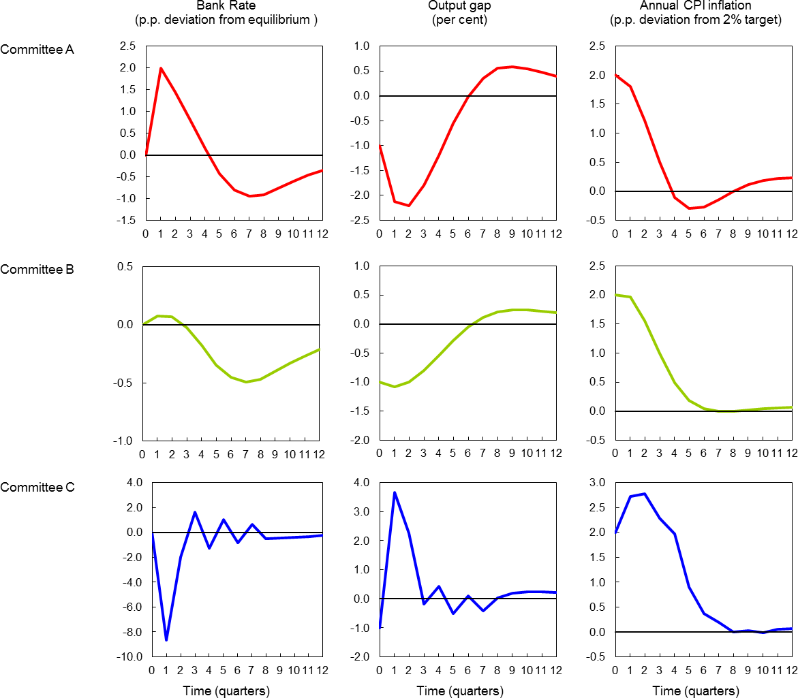This raises a legitimate question. If you can do something about it before then, and all you care about are deviations of inflation from the target – which in our remit “applies at all times” – why not try and eliminate them as soon as possible, like our monotheistic friends on Committee A? Shouldn’t the policy horizon simply be the shortest time delay between changes in interest rates and their impact on consumer prices?

Well one problem is that one can’t be entirely sure about what that delay is. As a famous economist once said, monetary policy seems to operate with “long and variable” lags.

More significantly, the MPC isn’t concerned solely with inflation. It is also asked to avoid “undesirable volatility in output”. And occasionally – in particular following shocks to costs or supply – there are trade-offs between the two. These can lengthen the optimal time over which to bring inflation back to target.

I think this had real relevance at the time I joined the MPC, in mid-2011. At that time, the economy looked a bit like the starting point of these simulations. After a tepid recovery there was still plenty of spare capacity in the economy. Companies said they were operating well below capacity; unemployment was still high. But thanks to a series of cost shocks, including the big depreciation of sterling’s exchange rate 2-3 years earlier, inflation was nonetheless well above target.

In response, the MPC might have behaved like Committee A, ramming up interest rates to get inflation back to 2% as quickly as possible. But that would almost certainly have pushed the economy back into recession. Instead it took a more balanced approach. As I tried to explain in a speech I gave later that year, the MPC had arguably tolerated the (then) high rate of inflation for longer than it might have done because the real side of the economy was so weak.

It signalled this choice more explicitly in early 2013. Following a further depreciation in the currency, rises in administered prices and the prospect of continued weak growth in productivity, inflation was thought “likely to remain above target for much of the forecast period”. But “attempting to bring inflation back to target sooner…would risk derailing the recovery” and it was therefore “judged appropriate to look through the temporary, albeit protracted, period of above-target inflation”.

I don’t think this was so exceptional. There is no inflation-targeting monetary authority that behaves so rigidly as to attempt to offset all shorter-term shocks to inflation, no matter the effects on the variability of interest rates and output. As the economist Lars Svensson puts it, “in practice, inflation targeting is always ‘flexible’, because all inflation-targeting central banks not only aim at stabilizing inflation but also put some weight on stabilizing the real economy”.

In the UK, this regard for the occasional trade-offs faced by monetary policy, and their implication for the planning horizon, was formally enshrined in the MPC’s remit in March 2013. The Committee is now required to “promote understanding of the trade-offs inherent in setting policy and… [to communicate] the horizon over which it is appropriate to return inflation to the target”. This description of the appropriate horizon is now a regular part of our communication, notably in the newly introduced Monetary Policy Summary that introduces both the Inflation Report and the Minutes of our meetings.

What of the current situation? The economy has also faced significant cost shocks in the past couple of years, this time in a negative direction. Commodity prices have fallen sharply, sterling’s exchange rate has risen. The combined impact has been enough to push CPI inflation down to zero.

We don’t face the same trade-offs as during the 2009-12 period, as output now looks much closer to

potential. Equally, there is a good argument for “looking through” some of the effects of these cost shocks. Faced with the same situation, Committee A would probably choose to loosen policy now in order to get inflation back to target as rapidly as possible. But, with the output gap projected to narrow further anyway,

and because the effects of lower commodity and import prices are likely to fade over time, it would probably then face the prospect of having to re-tighten policy thereafter, as inflation threatened to move above the target.

There was a very slight flavour of this in the MPC’s latest projections. The Committee has said it wants to get inflation back to target in “around two years and [keep] it there in the absence of further shocks”. Given all the other underlying assumptions in the forecast, the yield curve we faced at the time broadly does the first part of that job. But the central forecast rises a touch above target at two years and then drifts a little higher. For what it’s worth, and if only at the margin, that yield curve was thought likely to over-achieve.

# Stuff happens: Forecasts are not promises

Let me summarise these points: the MPC doesn’t have a concern only for inflation and, depending on the circumstances, it will face trade-offs with other objectives. This means the horizon over which it’s appropriate to return inflation to target can vary, and that the horizon will generally be beyond the earliest date at which policy can affect inflation. There are therefore many interest-rate paths that can prospectively achieve a particular rate of inflation two years ahead and one shouldn’t expect the central forecast at that date to be a failsafe indicator of future changes in interest rates.

|  |  |
| --- | --- |
| **Chart 2 Inflation forecasts explain a small proportion of subsequent average vote** | And it isn’t. Chart 2 plots the MPC’s central two-year inflation forecast against the average interest-rate vote on the Committee over the following three months. There’s a moderate correlation – on average, a higher inflation forecast is followed by votes for tighter rather than looser policy, conversely when it’s below target.  It’s hardly a tight relationship, however. The degree of fit – the proportion of the policy variation explained by the most recent inflation forecast – is only 8%, even less if you exclude the figure for 2008Q4 (the dot in the bottom  left-hand corner). |

Source: Bank of England and Bank calculations

What seems to have mattered much more is what actually happens to the economy. Chart 3 plots the same average vote against a contemporaneous survey measure of economic growth. The fit is much better,

particularly in data prior to 2008. Chart 4 then plots any residual correlation between forecasts and subsequent votes, controlling for the economic data. There is none.

Admittedly, it’s become harder to uncover simple reduced form relationships, such as the one in Chart 3, since the financial crisis. For much of that period interest rates have been pressed up against the effective lower bound: there hasn’t been any variation to work with. In addition, the pre-crisis relationship in Chart 3 exists because the MPC was generally confident about the stability of the underlying rate of supply growth; that hasn’t been the case in recent years1.

Comparing Chart 2 and 3 is in any case slightly unfair as it measures forecasts at one date against data on growth, which are released slightly later, over the following three months. But it does at least bear out an important point about our inflation forecasts, not to say all forecasts: while they do carry some information about the future, they are ultimately superseded by events.

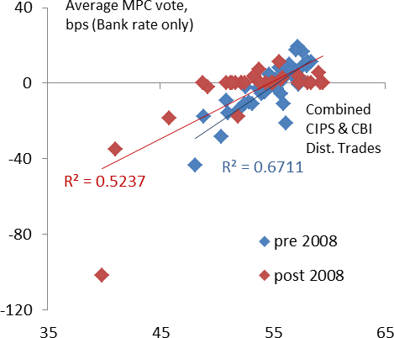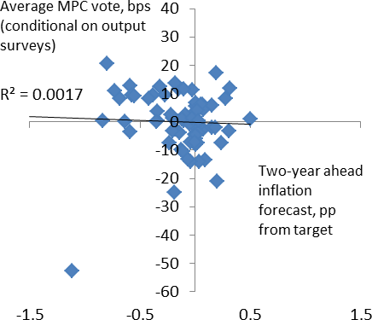This is a point that I – and countless other central bankers – have made before, of course. However, it does seem to bear repeating. Too often, it seems to me, what we communicate about the path of future policy, whether that’s direct or something backed out from forecasts, is treated as something close to an unconditional promise. But it can’t be. That’s because it’s the job of policy to respond to things that are unpredictable, in order to offset their effects, as best we can. So even if it’s the MPC that sets interest rates, in some narrow sense, it’s ultimately the economy that determines them. And our forecasts are intended not as some reliable guide of a particular policy path, but to help people understand how we see the nature and distribution of economic risks over the future.

|  |  |
| --- | --- |
| **Chart 3 Policy decisions better correlated with economic growth** | **Chart 4 Controlling for growth, IR forecasts uninformative about policy** |
| Source: ONS, CBI, Markit Economics, Bank calculations | Source: ONS, CBI, Markit Economics, Bank calculations |

1. Broadbent (2014)

# The “excess” volatility of bond yields

One way to think about the unpredictability of the future is to look at financial markets. Prices of financial assets are in many ways the embodiment of forecasts: they depend critically on how people think the future will evolve. So every time the price of an asset changes, someone’s forecast has gone wrong, or at least has had to be revised2. And as you know, asset prices change a lot!

In fact, if anything, as the economist Robert Shiller observed many years ago3, they appear to move too much. Equity prices are more volatile than seems justified by the variability of corporate earnings, as least over the sample period he considered; bond yields look to be more variable than reasonable forecasts of future short-term interest rates. Economists have therefore presumed that asset markets are prone to

“time-varying risk premia”.

In the case of bond markets, these would take the form of variations in the so-called “term premium” – by definition the gap between yields and expected future short rates. And although the term premium has generally been positive – on average, longer-term bonds have yielded more than rolling over a sequence of short-term bills – it could also be negative at times. For example, if investors worry about growing (if small) risks of some very bad economic outcome, that would tend to depress the yield on safe assets to levels below the expected future short rate. People are prepared to pay over the odds to insure against such tail risks4.

Unfortunately, it’s hard to distinguish these risk-induced movements in bond yields from those in the true expected path of future interest rates. But there are some pieces of evidence that, to me, are at least suggestive of such effects.

First, forward interest rates in the UK are very sensitive to news from the US, puzzlingly so. Chart 5 I’ve used before. It plots average responses of sterling yields, at two and ten-year maturities, to various bits of economic news. What’s most striking are the significant reactions to surprises in US payrolls releases. The UK is a relatively open economy, prone to shocks from elsewhere. As the largest economy in the world, the US is bound to exert an influence on our economy and the appropriate level of domestic interest rates. But

it’s hard to imagine that one learns more about inflationary pressure in this country from changes in US employment than from those in the UK itself. What seems more likely is that that US employment releases have effects on risk appetite, and this then leads to a high degree of co-movement – relative to that in pure forecasts – between forward interest rates in the two currencies.

1. Strictly speaking, I should limit this equivalence to unpredictable changes in asset prices. But that covers most of them.

3 The reference is Shiller (1979); see also Mankiw and Summers (1984) and Campbell (1995). In fact, the observation that bond yields fail to behave in accordance with the simple “expectations hypothesis” goes back much further, to Macaulay (1938).

1. Gabaix (2012)

Table 1, which gives the results of simple regressions of changes in UK interest rates on their US counterparts, suggests this might be a more general phenomenon. It shows that forward yields are much more closely correlated across the two markets than spot interest rates. This doesn’t disprove the expectations hypothesis. If, for example, country-specific shocks tended to die out pretty quickly, but common, global shocks were more persistent, you might expect to find this pattern. But that difference would have to be pretty stark to generate results of this sort. And there is evidence (much more careful and thorough than I’ve presented here5) that forward yields in different countries are, in fact, more volatile and more tightly correlated than the simple expectations hypothesis would suggest.

|  |  |
| --- | --- |
| **Chart 5 UK forward rates sensitive to US payrolls release** | **Chart 6 Market yields more sensitive than actual rate forecasts to shifts in risk premia** |
| Source: Bloomberg and Bank calculations; sample 2003-13 | Source: Bank of England and Datastream |

# Table 1: UK-US forward yields better correlated than spot rates

|  |  |  |
| --- | --- | --- |
| **Changes in yields: UK on US** | **Coefficient\*** | **R- squared** |
| 3-months | 0.37 | 0.12 |
| 1 year | 0.41 | 0.13 |
| 1 year 3 year forward | 0.54 | 0.35 |

Source: Bank of England and Bank calculations; Note: All coefficients are significant at 1%

Second, swings in measures of risk aversion are more closely correlated with market yields than with actual forecasts of future interest rates. There are, of course, good reasons why changes in perceived risks should affect both. Greater risk aversion can raise the cost of capital, reduce domestic investment and activity, and lower any reasonable expectation of the policy rate. (An effect of this sort was clearly at work in the last

1. Sutton (1997)

Inflation Report forecast: weaker equity prices led the Committee to revise down its forecast of domestic investment, partly offsetting the effect of a shallower yield curve on the projection for GDP growth.)

But the impact of such swings seems to be larger on market yields than on actual forecasts of interest rates. The red line in Chart 6 plots the gap, in months, between the date of the first UK rate rise implied by the sterling yield curve and that expected by professional forecasters. When the line goes up, markets are pushing out this “lift-off” date further than analysts. And you can see this tends to happen when risky assets do poorly (the blue line is an estimate of the risk premium). Conversely, the gap narrows when risk appetite improves. This pattern suggests that market interest rates might be influenced by more than the expected path of interest rates6.

To be clear, the MPC produces its forecasts on the yield curve as it is, not what it believes the market’s true expectation of future interest rates to be. So the fact that the two might differ does not, in and of itself, invalidate the sort of inferences we’ve been talking about. But it should, at the least, make one a little careful about describing the yield curve as “the market’s expectation of future interest rates”. It also means that, if an inflation forecast conditioned on the yield curve ends up away from target, that doesn’t necessarily mean we “disagree with the market”. It could just be that yields are being affected by something other than the market’s true expectation.

# Conclusion

Let me wrap up, summarising the main points.

The MPC’s headline forecasts are based on the assumption that interest rates follow the path priced into financial markets. That may or may not be the same thing as the true outside expectation of future rates. At times, the yield curve can move around for other reasons as well.

Nevertheless, many commentators then use the forecasts – in particular the central prediction of inflation two years ahead – to infer things about the likely path of interest rates over the future. Recently, there has been a particular focus on backing out implications for the date of the first rise in official interest rates.

That’s fine as far as it goes. If the central projection’s a long way from target, that can tell you something about the MPC’s view of the suitability of the yield curve – given, at least, all the other assumptions in its forecasts. In May 2009, after the first slug of QE, the Inflation Report forecast was well below target. This suggested that, unless the economy improved much faster than it expected, the Committee believed that monetary conditions would need to be looser than implied by the yield curve at the time.

1. Unlike professional forecasters, markets gets to update their opinions every minute of every day, and for most of the time are therefore at an advantage over analysts. But Chart 6 plots data only on days on which the analysts publish their projections, so the comparison is that much fairer. Nor, for what it’s worth, is there any evidence that we can find that markets predict actual interest rates any better than analysts.

As things turned out, that’s exactly what happened. But there are limits to how far this kind of reasoning should be taken. One particular problem, when it comes to the so-called “lift-off” date for interest rates, is that the yield curve is currently very flat. As a result, even relatively moderate changes in forward rates, prompted by unexceptional news about the economy, can result in big shifts in the date at which the yield curve first reaches some particular level. But that doesn’t mean the MPC’s views about future policy have moved so dramatically. If nothing else, this demonstrates the problem with focusing too obsessively on that particular date.

More generally, the MPC’s inflation forecast is a far from perfect indicator of interest rates. It involves lots of conditioning assumptions, not just forward interest rates, and any of these can change. Our understanding of the economy evolves over time and the economy itself is always subject to unforeseeable shocks.

Empirically, the behaviour of the economy matters more for interest rates than prior forecasts.

In addition, the MPC isn’t solely concerned with inflation anyway, still less its most likely rate at a fixed point in the future. That means that the target horizon for inflation is generally longer than the earliest point at which policy can affect it – there is therefore no single, unique path of interest rates that will do the job. It also means that the horizon itself can vary.

I will therefore conclude with something of an apology. For those in the audience wanting me to give a direct and unequivocal promise as to when Bank Rate will change, you will, I’m afraid, be disappointed. I can’t. But you should look on the bright side. If there is any value in listening to people like me, it is to help you with what is the best way to try and predict future interest rates - to forecast the economy yourselves (which is probably more interesting). After all, if the future were perfectly predictable we wouldn’t have to bother trying.

**References**

**Broadbent Ben,** 2014, “[Unemployment and the conduct of monetary policy in the UK”,](http://www.bankofengland.co.uk/publications/Pages/speeches/2014/752.aspx) Speech given at the

*Federal Reserve Bank of Kansas City 38th Economic Symposium, Jackson Hole, Wyoming*.

**Campbell John,** 1995, “Some lessons from the yield curve”, *Journal of Economic Perspective, Vol. 9, No.* 3.

**Eguren-Martin F. and N. McLaren**, 2015, “How much do UK market interest rates respond to macroeconomic data news?”, *Bank of England Quarterly Bulletin.*

**Gabaix Xavier** 2012, “Variable rare disasters: an exactly solved framework for ten puzzles in macro- finance”, [*Quarterly Journal of Economics,*](http://qje.oxfordjournals.org/) [*Volume 127, Issue 2,*](http://qje.oxfordjournals.org/content/127/2.toc) *Pp. 645-700.*

**Joyce M. and A. Meldrum**, 2008, “Market expectations of future Bank rate”, *Bank of England Quarterly Bulletin.*

**Macaulay Frederick,** 1938, “Some Theoretical Problems Suggested by the Movements of Interest Rates, Bond Yields, and Stock Prices in the United States Since 1856”, *National Bureau of Economic Research, pp. 33.*

**Mankiw G., and L. Summers**, 1984, “Do long-term interest rates overreact to short-term interest rates?”,

*Brookings Papers on Economic Activity*.

**Shiller Robert**, 1979, “The volatility of long-term interest rates and expectations models of the term structure”, *The Journal of Political Economy, Vol. 87, No. 6, pp 1190-1219.*

**Sutton Gregory**, 1997, “Is there excess comovement of bond of bond yields between countries”, *Bank for International Settlements, Working Paper No. 44.*